# Static/points/sketchNew.js

This block of code defines the width and height of the basketball court. Both variables are used for calculating the overlay and the coordinates of the points

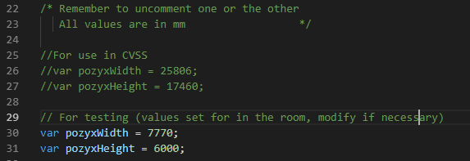

The first set of pozyxWidth and PozyxHeight consists of the width and height that are measured at Compassvale Secondary.

The second set of pozyxWidth and PozyxHeight is for development use, modifications of the width and height during development should go there.

If you are using the first set of variables, remember to comment out the second set of variables and vice versa

🡨----------------------------------------------pozyxWidth----------------------------------------------🡪

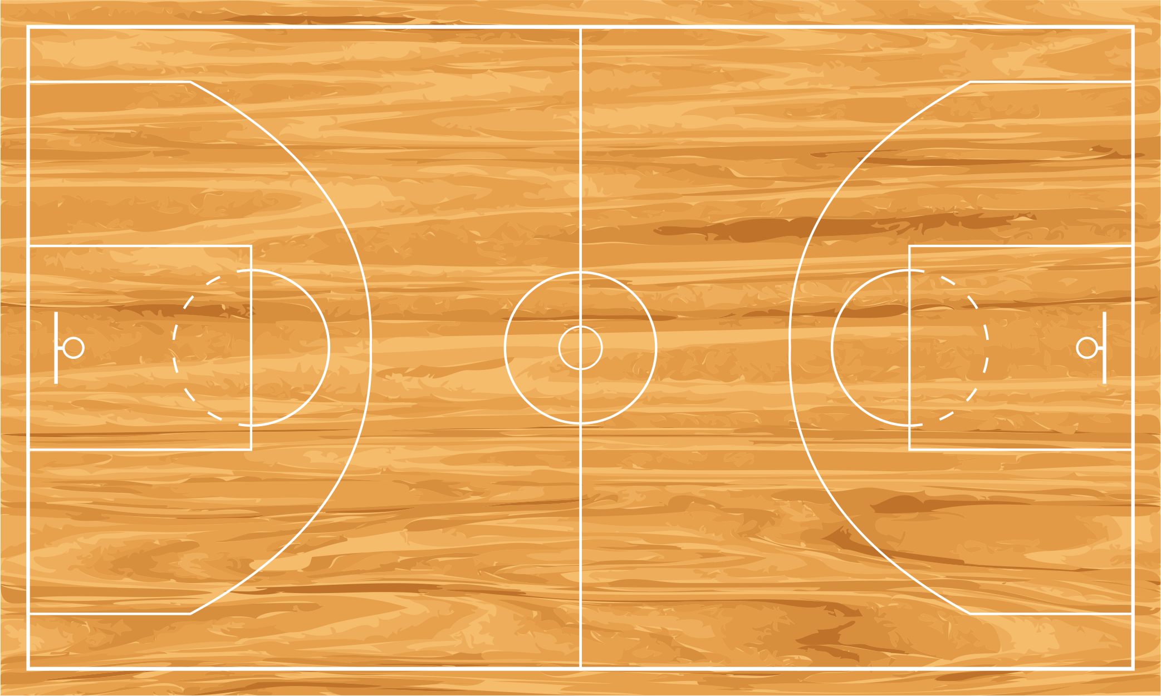

pozyxHeight

TODO: the width and height variables includes the areas that are outside the court. Need to figure out how to exclude the areas outside the court.

For reference,

Standard width of basketball court: 28.65m and standard height of basketball court: 15.24m

# Static/points/overlay.js

Contains the Overlay class for drawing overlays

# Hello.py

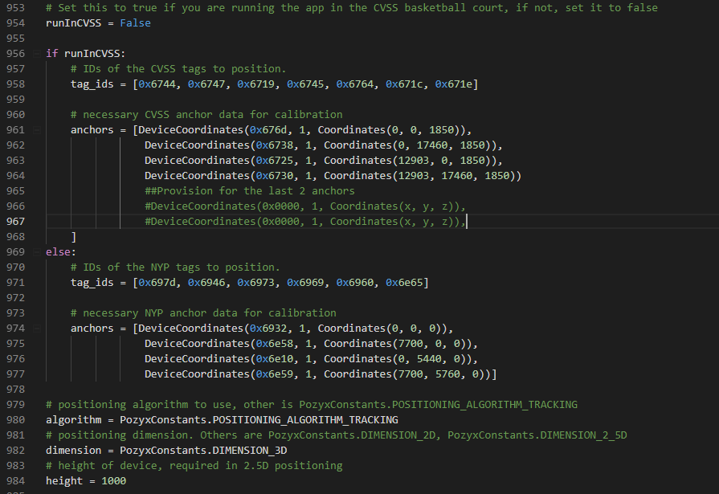

Attached screenshot contains the configuration data for initializing the pozyx tags and anchors

The anchors in CVSS are configured as follows:

0x6738 0x6730



0x676d 0x6725

# Sporta.sql

Use this script in MySQL Workbench to reset and reinitialize the ‘sportadb’ database

# References

The graphs in the statistics page uses the canvas.js library. Documentation can be found at:

<https://canvasjs.com/docs/charts/basics-of-creating-html5-chart/>

The visualization and overlay pages uses the p5.js library to draw points, tails and overlays.

https://p5js.org/reference/